**Abhinav Jain**

**500083840**

**EXPERIMENT-5**

Title: 5. Use of different SQL clauses and join

Objective: To understand the use of group by and having clause and execute the SQL commands

using JOIN

**1. Write the SQL Queries for the following queries (use emp_table and dept_table of Experiment 4).**

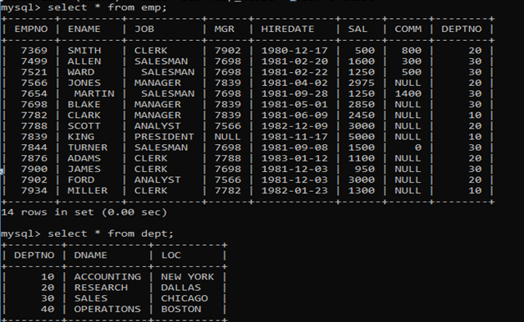

1. **List the Deptno where there are no emps.**

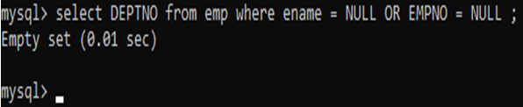

1. **List the No.of emp’s and Avg salary within each department for each job.**

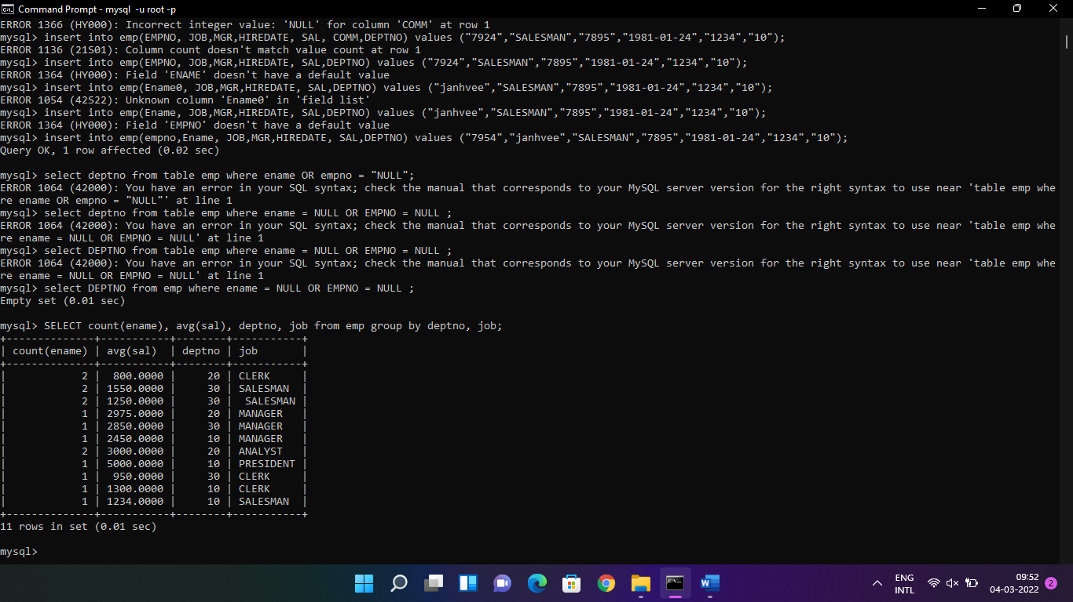

1. **Find the maximum average salary drawn for each job except for ‘President’.**

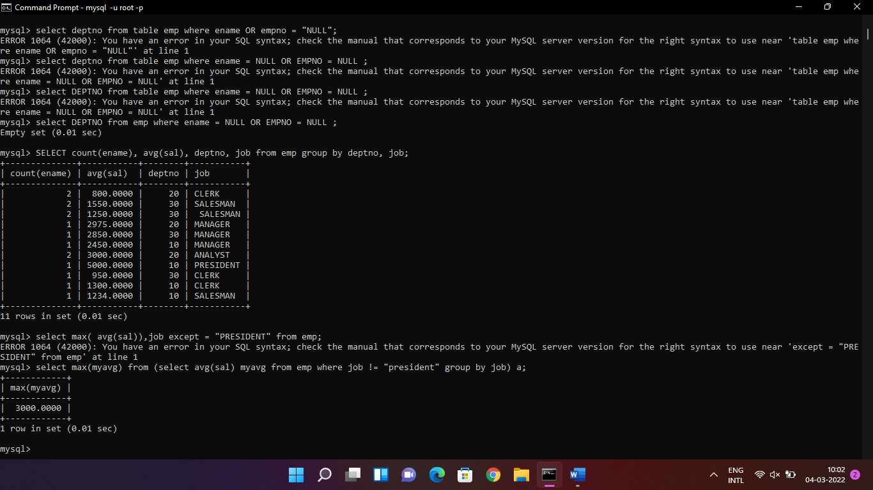

1. **List the department details where at least two emps are working.**

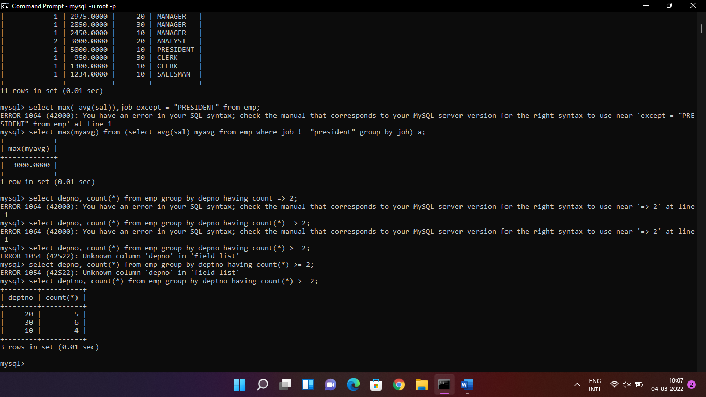

1. **List the no. of emps in each department where the no. is more than 3.**

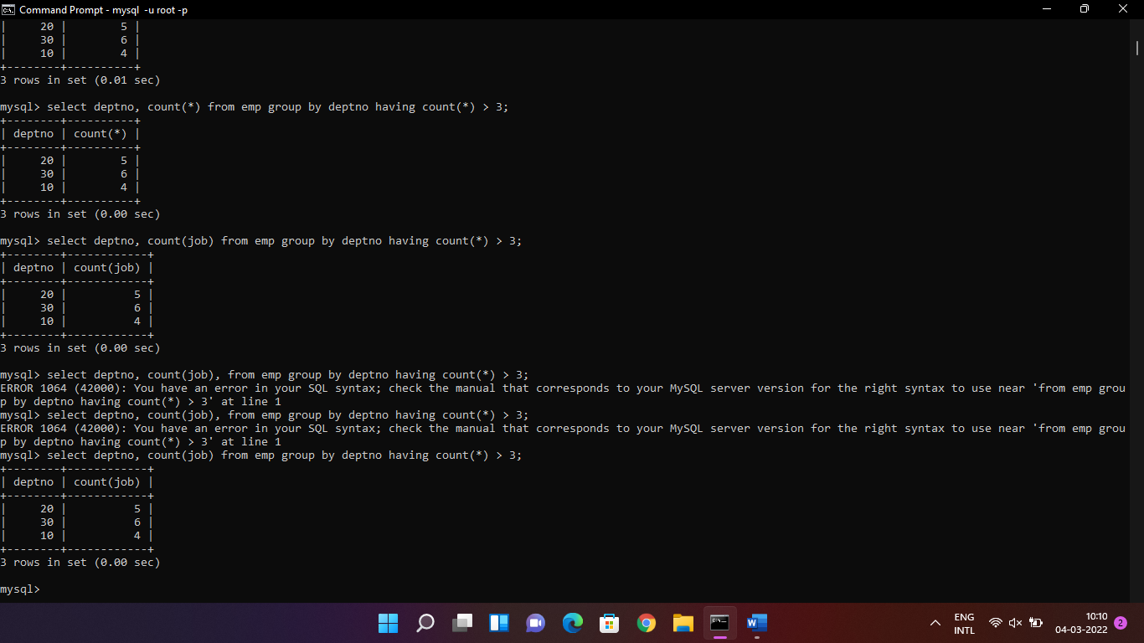

1. **List the names of the emps who are getting the highest sal dept wise.**

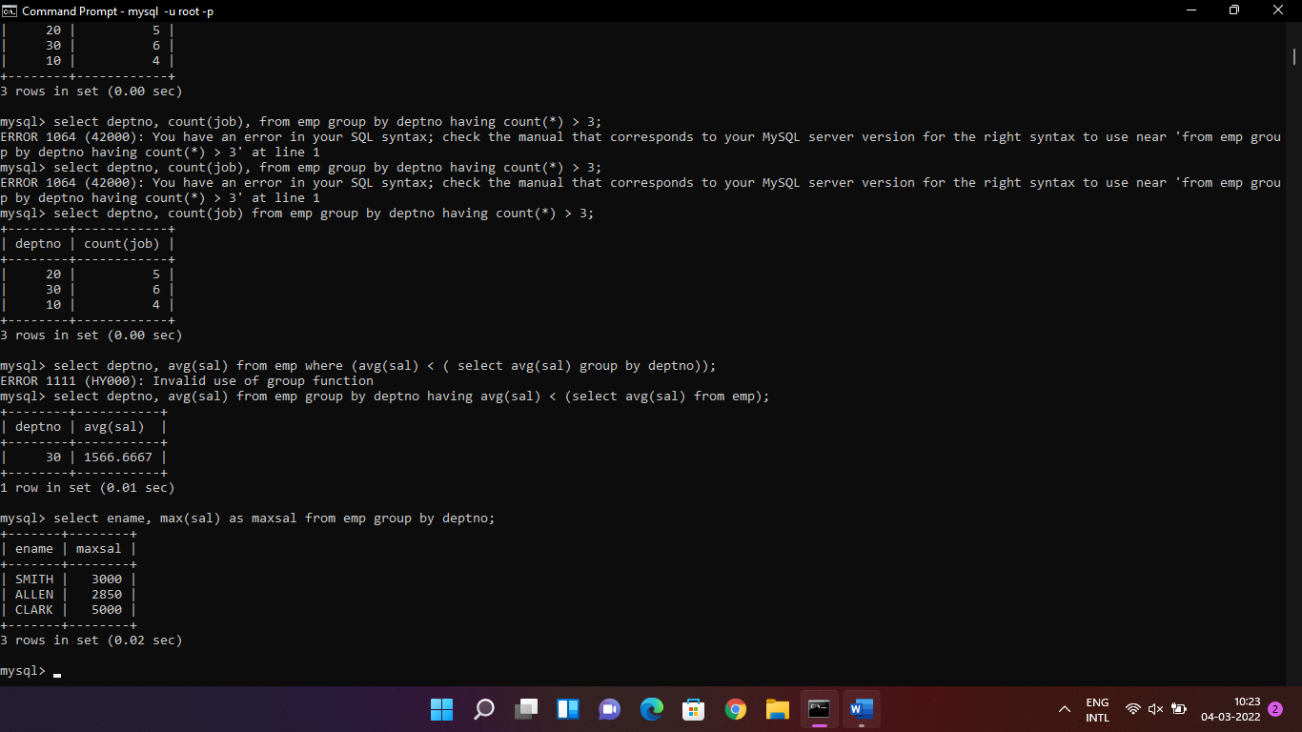

1. **List the Deptno and their average salaries for dept with the average salary less than the averages for all departments.**

